ABAON -

Functionality
Asset sale is the removal of an asset or part of an asset from the asset portfolio. This removal of an asset (or part of an asset) is posted from a bookkeeping perspective as an asset retirement.

Scenario
SAP provides the following types of retirement:
An asset is sold, resulting in revenue being earned. The sale is posted without a customer. The revenue earned is manually entered in the transaction. (Illustrated here)
An asset is sold, resulting in revenue being earned. The sale is posted against a clearing account.
An asset has to be scrapped, with no revenue earned. (Illustrated here)
An asset is sold to an affiliated company (refer to Manual Posting of Intercompany Asset Transfer/Retirement).

Requirements
None.

Menu Path | Accounting → Financial Accounting → Fixed Assets → Posting → Retirement → Retirement w/Revenue → ABAON - Asset Sale Without Customer
Transaction Code | ABAON

1. Double Click on ABAON - Asset Sale Without Customer

Enter Asset Transaction: Asset Sale Without Customer

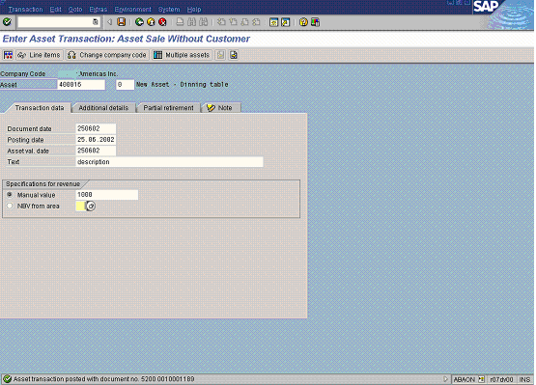

2. Update the following fields:

Field Name | Field Description | Values
Asset | Asset number. | Example: 400016
Document date | Date the transaction occurred | Example: 250602
Posting date | Date that the business transaction occurred | Example: 250602
Asset val. date | The asset value date is the value date for Asset Accounting. | Example: 250602
Text | Contains an explanatory text on the line item. | Example: description
Manual value | Revenue that was realized due to the sale of an asset or part of an asset. The system determines the gain/loss as the difference between the revenue and the net book value of the asset being retired. When the retirement involves acquisitions from prior fiscal years and acquisitions from the current fiscal year, the system also divides the sales revenue proportionatelly. | Example: 1000
3. Click the Enter button.
4. Click Button .

Enter Asset Transaction: Asset Sale Without Customer

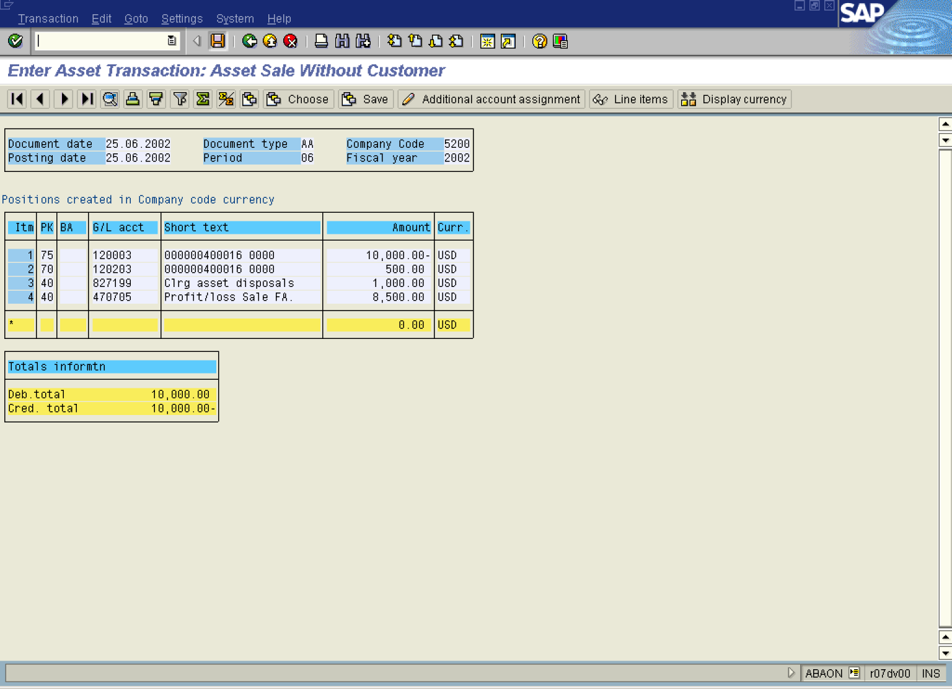
5. Click the Save button.
6. The message bar displays “Document xxxxxxx was posted”

